A PRELIMINARY REPORT ON

Stress Detection over Social Interaction Using Machine Learning

SUBMITTED TO THE Dublin Business School, Dublin-Ireland
IN THE PARTIAL FULFILLMENT OF THE REQURIEMENTS FOR THE AWARD OF THE DEGREE

OF
MSc. Data Analytics

Submitted by
Vhawale Divya Deepak 10612243



MSc. Data Analytics
Dublin Business School
Dublin,Ireland

CERTIFICATE

This is to certify that the seminar report entitled

Stress detection over social interaction using machine learning

Submitted by
Vhawale Divya Deepak 10612243

is a bonafide student of this institute and the work has been carried out by her under the Supervision of prof. Mina Ghahremanzamaneh and it is approved for the partial fulfilment of the requirement of Dublin Business School, for the award of the degree of MSc. Data Analytics

Place: Dublin, Ireland

Date:
29/08/2023

Acknowledgement

We would like to express our gratitude to all those who helped us to complete this work. We want to thank our guide (Prof. Mina Ghahremanzamaneh) for her continuous help and generous assistance. She helped in a broad range of issues from giving us direction, helping to find the solutions, outlining the requirements.

Vhawale Divya Deepak 10612243

Contents
1 Abstract 6
2 Chapter 1 7
2.1 Introduction - Overview 7
2.2 Motivation 13
2.3 Problem Definition and Objectives 13
2.4 Project Scope 15
2.5 Methodologies of Problem solving 15
3 Chapter 2 16
3.1 Literature Survey 16
4 Chapter 3 17
4.1 Software Requirements Specification 17
4.1.1 Assumptions and Dependencies 17
4.1.2 Software Interface 17
4.1.3 Communication Interface 17
4.1.4 User Interface 17
4.1.5 Non Functional Requirements 17
4.1.6 Performance Requirement: 18
4.1.7 Safety Requirement 20
4.1.8 Security Requirement 20
4.1.9 Software Quality Attributes 20
4.1.10 Database description 21
4.1.11 Software Specification 22
5 Chapter 4 23
5.1 Analysis Models: NLP Model to be applied. 23
5.1.1 Natural Language Processing (NLP) 23
5.1.2 Sentiment Analysis 28
5.1.3 System Architecture: 31
6 Chapter 5 37
6.1 Class Diagram 37
6.2 Sequence Diagram 38
6.3 Deployment Diagram 39
7 Chapter 6 40
7.1 Conclusions 40
7.2 Future Work 41
7.3 Applications 42
7.4 Advantages 43
7.5 REFERENCES 44

List of Figures

Figure 2.5 1 16

Figure 5.1 1 24

Figure 5.1.2 1 30

Figure 5.1.3 1 33
Figure 5.1.3 2 36

Figure 6.1 1 Class Diagram 39

Figure 6.2 1 Sequence Diagram 40

Figure 6.3 1 Deployment Diagram 41

Abstract

Stress has arisen as a serious public health problem in today's fast-paced and demanding environment, affecting individuals' well-being and general quality of life. Early identification and intervention are critical for reducing the negative consequences of stress. This abstract describes a unique method to stress detection that use Machine Learning (ML) techniques, namely Natural Language Processing (NLP), to recognize and analyse stress symptoms in textual data.

The suggested technique takes use of the quantity of textual material generated by individuals, such as social media postings, online journals, and personal notes, which frequently indicate their emotional condition. This project intends to use NLP to automatically assess the language patterns, syntactic structures, and semantic clues encoded in the text to infer the existence and level of stress.

Data collection, preprocessing, feature extraction, model construction, and validation are key phases in this technique. To begin, several textual sources are gathered to create a complete dataset. Tokenization, stemming, and stop-word removal are among the preprocessing procedures used to sanitize the text and improve its eligibility for analysis. NLP approaches such as TF-IDF (Term Frequency-Inverse Document Frequency) and word embeddings such as Word2Vec are then used to extract features from the processed text. These characteristics are fed into multiple ML algorithms.

Chapter 1

Introduction - Overview

Stress is a common and complicated phenomena that affects people in many ways, including their physical, emotional, and mental well-being. Understanding and treating stress has become increasingly important as societies grow more fast-paced and linked. Workplace pressure, personal connections, and cultural expectations are all sources of stress. One fascinating approach to researching stress is to look at it through the prism of social interactions. It is also prevalent psychological issue that can have a negative impact on a person's well-being and productivity. Early stress identification enables for early treatment and enhances overall quality of life. Social interactions, such as conversations and social media messaging platforms, can give useful insights regarding people's stress levels.
Stress detection is critical for understanding human well-being and improving mental health support systems. People are engaging in social interactions more regularly than ever before, thanks to the advancement of technology and the availability of online communication platforms. These contacts, whether in person or online, can have a major influence on an individual's stress levels. We may dive into the subtle indications hidden in chats, text messages, or social media postings by applying natural language processing (NLP) and machine learning approaches. These indicators may reflect underlying emotional states suggestive of stress, such as worry, irritation, or tension. The capacity to sense stress in social interactions has several important advantages:

Machine learning techniques such as logistic regression, support vector machines, and neural networks can be used to detect stress in social interactions automatically. These strategies usually entail preprocessing the text input, identifying relevant characteristics, and training a classifier to predict the stress label. The accuracy, precision, recall, and F1-score measures may be used to evaluate the performance of these models. Among the applications of stress detection using machine learning over social interactions are mental health monitoring and individualized stress management. These emotions can also be used to assess stress or sadness. Finally, the ML models and have a high detection rate. This study is beneficial to a person's mental health. The findings are analysed using multiple macro and micro metrics and show that the trained model recognizes the status of emotions based on social interactions.
Early Intervention: Recognizing stress signs in social interactions early allows for early intervention and assistance. This preventative strategy can save stress from worsening into more serious mental health problems.
individualized Support: Stress detection driven by NLP can give individualized insights into an individual's stress triggers a coping process. This data can help mental health experts adapt effective therapies. Remote Monitoring: Online interactions enable continual stress monitoring, offering a broader view on an individual's well-being. This is especially useful in today's digital era, when most contact takes place digitally.

Insights into larger societal stress trends may be gained by collecting and analysing stress data from various social interactions. This data can help policymakers develop social stress reduction initiatives.

Stress detection using machine learning over social interactions is an emerging field that aims to automatically identify and measure stress levels in individuals during their social interactions. Social interactions can be a major source of stress for many people, and detecting stress in real-time can be valuable in several contexts, including mental health, social psychology, and workplace productivity. Machine learning algorithms are well-suited for this task, as they can learn to recognize patterns in complex data sets, such as physiological signals (e.g., heart rate variability, skin conductance) and behavioural cues (e.g., speech rate, facial expressions), that are indicative of stress. By analysing these signals, machine learning models can accurately classify stress levels and provide valuable insights into an individual's emotional state. Stress detection using machine learning over social interactions has several potential applications, including stress management interventions, workplace productivity optimization, and mental health screening. However, it also raises important ethical considerations around privacy and consent, as the collection and analysis of personal data may infringe on individuals' rights. As such, careful consideration and transparent communication with participants are critical to ensuring ethical practices in this field.

Social connections are important in both producing and detecting stress. Humans are social animals by nature, and the quality and type of our connections with others may have a significant influence on our psychological well-being.
Stress Factors in Social Interactions:

a. Social Pressure: Individuals can be subjected to many sorts of pressure during social interactions, such as societal expectations, peer pressure, and the urge to comply. As individuals seek to fulfill perceived norms and fit in with social groups, these demands can contribute to stress.Interpersonal disputes, misunderstandings, and disagreements in social encounters can all contribute to increased stress levels. The emotional toll of these disagreements, especially if they are not addressed successfully, might show as stress.

b. Relationship Stress: Relationships with family, friends, coworkers, and love partners may all be stressful. Chronic stress can be exacerbated by unresolved issues, a lack of support, or harmful dynamics within these relationships.

c. Excessive Self-Disclosure: When stressed, individuals may engage in excessive self-disclosure, using social contacts to vent and seek support.

d. Physical Indicators: During social encounters, stress can present physically as increased heart rate, fidgeting, or nervousness. These signals can provide information about a person's stress state.

Stress Reduction and Social Support:

Positive social contacts, on the other hand, can operate as potent stress absorbers. Stressors may be mitigated by having a strong support network where individuals feel heard, understood, and respected. Participating in meaningful discussions, discussing problems, and receiving emotional validation can help to develop a sense of belonging and reduce stress.

Approach, Methods, and Technologies Overview

In this article, we investigate the novel field of stress detection in social interactions by combining Natural Language Processing (NLP) and machine learning approaches. Our major goal is to use linguistic patterns and emotional clues contained in chats, text messages, and social media interactions to uncover stress indicators. Strategy: We take a multi-step strategy that includes data collection, preprocessing, feature extraction, model selection, and assessment.

- Individuals' Reactions to Stress:
- Emotional Influence:
- Stress can cause a variety of emotional reactions, including:
- Anxiety: Concern, anxiety, or apprehension about the future.
- Irritability: The ability to get angry, frustrated, or short-tempered quickly.
- Mood Swings: Rapid changes in emotions ranging from despair to rage.
- Depression is characterized by feelings of sadness, hopelessness, and a loss of interest in activities.
- Overwhelm: The inability to handle or deal with the pressures of daily life.
- Stress can have an impact on cognitive functioning, resulting in: Difficulty Concentrating: Having difficulty focusing on activities or making judgments.
- Memory problems include forgetfulness and difficulties recalling facts.
- Negative Thoughts: Thinking that is self-critical or gloomy.
- Racing Thoughts: Having a continually occupied and agitated mind.
- Stress can have an effect on behavior, resulting in:
- Changes in Eating Patterns: Stress-related overeating or loss of appetite.
- Insomnia or interrupted sleep patterns are examples of sleep disturbances.
- Avoiding social connections or isolating oneself is referred to as social withdrawal.
- Aggression: Anger or aggression in reaction to pressures.
- Substance Abuse is defined as the use of alcohol or drugs as a coping technique.
- Physiological Effects: Stress causes physiological changes in the body, including:
- Increased Heart Rate: The body prepares for a "fight or flight" reaction.
- Elevated blood pressure is caused by the release of stress hormones.
- Muscle tension causes headaches, neck discomfort, and back pain.
- immunological System Suppression: Prolonged stress can inhibit immunological function.
- Stress can cause stomach-aches, indigestion, or irritable bowel syndrome.

- Long-Term impacts: Chronic stress, if not controlled, can have substantial long-term impacts on health and well-being. It has been connected to a variety of health issues, including:
- Cardiovascular Disease: An increased risk of heart disease.
- Anxiety and despair are exacerbated by mental health disorders.
- Digestive Disorders: Exacerbating illnesses such as irritable bowel syndrome.
- Autoimmune disorders have the potential to exacerbate immune-related illnesses.
- Cognitive Decline: The deterioration of memory and cognitive function over time.

Individuals' social connections have an important role in both producing and treating stress. The influence of social contacts on stress is multifaceted and varies depending on the nature of the connections, support systems in place, and context of the interactions. Here's an explanation of how social interactions may both cause and relieve stress:
Stress Causes:
Interactions with friends, coworkers, or family members can occasionally lead to social pressure, in which people feel compelled to adhere to expectations, norms, or standards. Stress might result from the pressure to fit in or satisfy particular societal standards.

Disagreements, disagreements, and misunderstandings in social connections can lead to increased stress levels. Conflicts with friends, family, or workplace can cause mental distress and tension.

Constant comparison with others in terms of achievements, attractiveness, or lifestyle can lead to emotions of inadequacy and jealousy. As people seek to reach perceived standards, these feelings can add to stress.

Feelings of Social Rejection or Isolation: Feelings of social rejection or isolation can cause stress. Humans are fundamentally social organisms, and a lack of social support or isolation can have a detrimental influence on their emotional well-being.

Stress Reduction: Social assistance: Positive social relationships can give emotional and practical assistance during times of stress. Individuals who have a network of friends, family, and coworkers who give understanding, empathy, and support can better manage their stress.

Venting and Emotional Expression: Talking with trustworthy people allows people to express their emotions, vent their sentiments, and relieve tension. Sharing can bring both relief and affirmation.

Diversion and Relaxation: Engaging in pleasurable social activities can provide a diversion from pressures. Spending time with loved ones, engaging in hobbies, and having fun might help to divert attention away from worries.

Positive Influence: Positive social connections can boost self-esteem and self-worth. Others' encouragement and praise can help to counteract negative self-talk and promote a more cheerful mindset.

Physical contact, such as hugs or handshakes, can cause the release of oxytocin, a hormone related with stress reduction and relaxation. Physical encounters can elicit sentiments of safety and comfort.

Sharing Coping tactics: Being a member of a social group may expose people to a variety of coping tactics. Stress management abilities may be improved by learning from the experiences of others and using effective coping techniques.

There is no accepted definition of stress. There is no single definition of stress that is widely acknowledged. This can make identifying stress in textual data challenging since different people may use various terms or phrases to convey their stress.

Stress is context dependent. The context in which a word or phrase is used might change its meaning. This can make identifying stress in textual data challenging since the same word or phrase may be used to represent tension in one context but not in another.

Individual variations in stress manifestation. People exhibit their stress in a variety of ways. Some people show their tension openly, while others keep it hidden. This can make recognizing stress in textual data problematic, as there is no one-size-fits-all strategy to identifying stress.

Language use can be customized. People use language in a unique way, making it challenging to detect stress in textual data. For example, some people may convey their stress using slang or emojis, whilst others may use more official language.

Co-occurring mental health issues. Other mental health problems, such as anxiety and depression, can co-occur with stress. This can make identifying stress in textual data challenging since the symptoms of stress may be hidden by symptoms of other conditions.

Despite these obstacles, there are a variety of ways for detecting stress in textual data. Among these methods are:

Linguistic analysis: This methodology use statistical methods to discover stress-related words and phrases.

Machine learning: This approach use algorithms to identify stress-related patterns in textual data.

Human review: In this method, people examine and analyse textual data in order to identify stress.

The optimum method for detecting stress in textual data will differ based on the data collection and the desired level of accuracy. Researchers and developers can build more effective approaches for recognizing and managing stress if they understand the problems of identifying stress in textual data.

Research Question

Can machine learning be used to identify stress levels in real-time social interactions?

Keywords

Decision tree, Sentiment analysis, Logistic Regression, Random Forest, natural language processing, machine learning, Stress detection, social media, mental health.

Motivation
In light of its potential to improve mental health evaluation, intervention, and support, the field of stress detection using Natural Language Processing (NLP) has received a lot of interest. Stress, a common psychological phenomenon, can have a significant impact on a person's well-being, productivity, and general quality of life. However, detecting and managing it can be difficult, with traditional treatments depending on self-reporting or professional examinations.

Problem Definition and Objectives
The challenge is to provide a system that uses Natural Language Processing (NLP) techniques to detect and assess stress levels in individuals based on their interactions on social media platforms. The prevalence of stress-related disorders, as well as the increasing use of social media, highlight the need for a trustworthy tool that can recognize stress signs from textual data. The research intends to address this issue by developing an effective stress detection system.

Objectives:

- Create Data Collection Infrastructure: Put in place methods to gather various social media data, such as text-based material from platforms such as Twitter, Facebook, and forums.

- Data Preprocessing for NLP: Create a strong data preprocessing pipeline to clean and organise the social media text collected.

- Emotional Analysis Build machine learning models (such as Naive Bayes and SVM) to perform sentiment analysis on social media text.

- Train models to correctly categorize sentiments as positive or negative based on context.

- Emotion Detection and Stress Indicators: Create algorithms that associate sentiment analysis findings with certain emotional states.

- Create ways for identifying possible stress indicators in the text by evaluating emotional patterns.

- User Interface and Visualization: Design an intuitive and user-friendly interface that allows users to easily engage with the system.

- Real-time Analysis Capability: Use real-time or near-real-time sentiment and emotion analysis to present users with timely information.

- Maintain user involvement by ensuring low latency in generating analytical findings.
- Validation of Accuracy: Examine the accuracy of sentiment classification and emotion detection using labeled datasets.

- Validate the system's ability to appropriately recognize stress signs.

- Data Privacy and Anonymization: During sentiment and emotion analysis, utilize data anonymization techniques to preserve user privacy.

- Ensure that data protection requirements and ethical issues are followed.

- Actionable Stress Insights: Provide customers with actionable stress insights based on observed emotional patterns and stress markers.

- Provide recommendations for stress management measures based on the findings of the analysis.

- Documentation and reporting:

- Document the system's technical components, such as techniques, algorithms, and so on.
- Prepare concise and informative reports on the capabilities, limits, and results of the system.

- Ethical Concerns and Bias Reduction:

- To ensure fair and impartial outcomes, address any biases in sentiment analysis and emotion recognition.
- Follow ethical data usage norms and respect users' privacy and permission.

- Scalability and Prospective Expansion:

- Create a system design that allows for scalability in order to handle growing data volume and user activity.
- Consider future additions such as language support and integration with other social networking networks. By attaining these goals, the project hopes to create a stable and dependable system that uses NLP to identify stress levels in people based on their social interactions. The project's findings will help to improve knowledge of users' emotional well-being and provide insights for stress management measures.

Project Scope

The project's focus on stress detection using Natural Language Processing (NLP) includes the creation of a complete system that uses NLP techniques to identify stress levels in individuals based on their online activities, namely social media postings and comments. Through textual data analysis, the project intends to produce a dependable and user-friendly tool that contributes to understanding and managing stress. However, the project's is to create a reliable and accurate system that improves comprehension and stress management by analysing social media information using NLP. Here the goal is to improve users' mental health by offering practical insights about their emotional states gleaned through internet interactions.

Methodologies of Problem solving

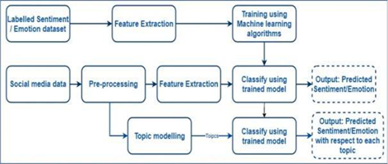
The study employs both secondary and primary data sources. It is cross-sectional research utilizing a combination of quantitative and qualitative approaches to determine the influence of social and emotional data related with social media data and its use. The study's goal is to develop models for sentiment and emotion identification that may be utilized for stress management; the models are also evaluated using primary data. The purpose of this study is to recognize a user's sentiment or feelings towards various subjects or domains using Natural Language Processing (NLP), a branch of artificial intelligence (AI). It enables robots to interpret and comprehend human language in order to do repetitive activities automatically. Machine translation, summarization, ticket categorization, and spell check are a few examples. The proposed model's block diagram. Before we begin constructing the analyser, we must first clean the data by completing the following procedures. Tokenization, pattern removal, stop word removal, and stemming are all performed. Identifying the relevant input properties is a critical step in building a classifier. Then you can learn how to encode such characteristics. The Bag-of-words approach is used to extract feature vectors. We develop our machine learning model for sentiment analysis and emotion recognition once the data is available. These machine learning algorithms are capable of predicting sentiment or emotion These machine learning algorithms are capable of predicting sentiment or emotion. To evaluate the performance of our model, we employ accuracy, F1 score, and confusion matrix.

Figure 2.5 1

Chapter 2

Literature Survey

Sentiment analysis has made amazing advances in recent years, evolving from a basic binary classification problem to a more complex technique that captures the vast spectrum of human emotions and expressions. Initially, sentiment analysis was primarily focused on binary classifications, with sentiments assigned to just two polarized groups. However, the picture changed with the innovative work of Pak and Paroubek [5,] who established a more complete model capable of classifying tweets into three separate classes: objective, positive, and negative.

- The unique strategy taken by Pak and Paroubek includes the building of a robust dataset by collecting tweets using the Twitter API. They used emoticons in tweets as sentiment indicators and used this data to train a sentiment classifier. The use of the Naive Bayes approach, augmented with N-gram analysis and Part-of-Speech (POS) tagging, was crucial to their model. This mix of techniques allowed them to capture contextual subtleties and language patterns, improving sentiment categorization accuracy. However, their technique was limited by the training set's variety, since it primarily consisted of tweets with emoticons, potentially leading to biased conclusions.

- Following research studies [6,7,8,9,10] have investigated effective data preparation strategies, with a special focus on tweets, to meet the issues given by the unstructured nature of social media information. Researchers have emphasized the necessity of removing terms that offer nothing to the analysis, such as stop words, symbols, and punctuation marks, from tweets. Furthermore, the process of reducing words to their basic form, known as lemmatization, is thought to be critical for producing more accurate sentiment analysis results.

- The progress of sentiment analysis from basic binary classifications to multi-class categorizations shows the field's dedication to understanding the complexities of human emotions portrayed in text. Pak and Paroubek's pioneering work [5] established the groundwork for more advanced techniques that take into account a larger range of emotions. Furthermore, continuous research into data pretreatment approaches indicates the field's commitment to refining procedures and improving sentiment analysis accuracy, particularly in the context of social media data such as tweets. These breakthroughs offer more nuanced insights into the intricate interaction of emotions and language as sentiment analysis continues to develop.

Chapter 3

Software Requirements Specification
The "Software Requirements Specification" (SRS) describes the project's functional and non-functional requirements for stress detection using NLP. It specifies the objectives, scope, user interfaces, performance criteria, safety and security measures, data description, possible benefits and uses, and future development for the program. The SRS also specifies technical aspects such as software interfaces, system restrictions, and procedures for stress detection in social interactions utilizing Natural Language Processing techniques.

Assumptions and Dependencies

The sensors are continuously dependent on Wi-Fi connection and power supply.

Software Interface

The software interface orchestrates the flow of data and interactions between various system modules, ensuring accurate sentiment, emotion, and stress analysis based on social media interactions.

Communication Interface

Wireless communication

User Interface

The user interface aims to provide users with clear insights into their emotional well-being derived from their social media interactions. It offers actionable recommendations for stress management based on the analysis results, fostering a positive impact on users' mental health.

Non Functional Requirements

The project aims to ensure that the stress detection system provides a high-performance, accurate, secure, and user-friendly experience while adhering to ethical and regulatory considerations.

Performance Requirement:

1. Analysis in Real Time:

- The system must do sentiment analysis and emotion identification in real-time or near-real-time, with reaction times no more than two seconds per interaction.
- It should provide users with timely information while retaining the immediacy needed for successful stress detection.

2. Flexibility:

- The system must be scalable in order to accommodate rising amounts of social media material without considerable performance reduction.
- It should be able to support a user base ranging from a few hundred to thousands of concurrent users.

3. Multiple Users:
- The system should be capable of supporting at least 500 concurrent users without facing performance constraints.
- It should be able to manage several users engaging with the system at the same time.

4. Tolerance for Latency:

- For real-time interactions, the system should have low latency, with sentiment and emotion analysis findings accessible within milliseconds.
- When asking the system for insights, users should have minimum wait times.
5. Use of Resources:

- During high usage times, the system's resource consumption, including CPU and memory usage, should remain below acceptable bounds.
- It should be tuned to ensure that hardware resources are used efficiently while maintaining performance.
6. Precision and dependability:

- The system's sentiment and emotion analysis findings must have a minimum accuracy of 90% for sentiment categorization.
- In stress detection, the system should continuously give correct insights while avoiding false positives and false negatives.

7. Handling Errors:

- To handle unforeseen events, such as data abnormalities or connectivity failures, the system must have strong error-handling capabilities.
- When mistakes occur, it should manage them gently and give users with clear error messages.

8. Data Transfer Rate:

- The system should be able to process and analyse at least 1000 social media postings per minute.
- To support high-frequency social media interactions, it should enable effective data throughput.

9. Safety and privacy:

- The security features of the system should not add considerable overhead, ensuring that data processing and analysis remain efficient.
- It should protect user data while without affecting system performance or responsiveness.

Safety Requirement
These security criteria define the safeguards that must be in place to secure user data privacy, ethical data usage, transparent analysis, and responsible reporting of mood and emotion analysis results. By following these safety criteria, the system intends to provide users with a secure and trustworthy environment while also giving significant insights regarding stress detection based on social media interactions.

- Data Privacy and Security
- Anonymization of User Data
- Ethical Data Usage

Security Requirement

- These security requirements specify the means and protections necessary to secure user data, prevent unwanted access, and preserve the mood and emotion analysis system's integrity. By addressing these security concerns, the system attempts to provide users with a safe environment while also protecting the confidentiality and integrity of their data.
- The system shall implement strong encryption methods for storing and transmitting user data, including social media content and analysis results.
- The system shall require secure authentication mechanisms for users and administrators accessing the system.
- The system shall undergo regular vulnerability assessments and penetration testing to identify and address potential security vulnerabilities.

Software Quality Attributes

Our software has many qualities attribute that are given below: -

- The system is portable.
- It provides privacy to data.

Database description

The sentiment and emotion analysis system is based on multiple types of data collected from social media networks, with a primary focus on user tweets. This information forms the basis for sentiment categorization, mood detection, and stress analysis. The following data elements are critical to the system's operation:

1. Posts on social media:

- User-generated postings, comments, and interactions via platforms such as Twitter are examples of this.
- Social media postings are text-based pieces of material that feature a mix of words, phrases, and symbols.

2. Metadata for Users:

- User metadata includes information on the people who create social media material.
- Usernames, profile descriptions, follower numbers, and other pertinent profile data are all included.

3. Emotional Labels:

- To train machine learning models, a labelled dataset of social media postings with positive, negative, or neutral attitudes is required.
- Each post should be tagged with the sentiment category that corresponds to it.

4.Emotion Mapping:

- The mapping of feelings to specific emotions is critical for detecting stress.
- Sentiment categories should be linked to relevant emotions so that the algorithm can infer emotional states.

5.Data on User Interaction:

- User interactions, such as likes, retweets, comments, and shares, give context for sentiment and emotional analysis.

6. Data that has been anonymized:

- The acquired social media postings and user information should be anonymised to protect data privacy and security.
- To safeguard user privacy, personally identifiable information (PII) should be substituted by pseudonyms.

7. Model Evaluation Data:

- To test the performance of sentiment analysis, emotion recognition, and stress analysis algorithms, a different dataset is necessary.
- Posts with known sentiment labels and related stress levels should be included in this collection.

8.Data on User Interaction:

- User interactions, such as likes, retweets, comments, and shares, give context for sentiment and emotional analysis.
- This information shows the amount of interaction and influence of social media material.

Software Specification

- Operating System: Windows 11
- Coding Language: Python
- IDE: Google Colab

Chapter 4

Figure 5.1 1

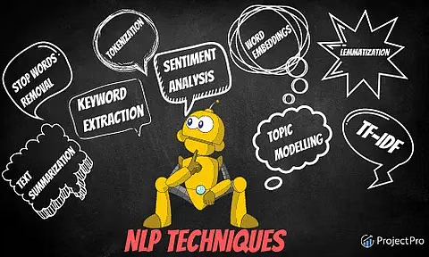
Analysis Models: NLP Model to be applied.

Natural Language Processing (NLP)
Natural Language Processing (NLP) is an artificial intelligence area that studies the interaction of computers and human language. Its objective is to allow computers to understand, interpret, and produce meaningful and valuable human language. To process and analyse text data, NLP employs a combination of linguistics, computer science, and machine learning approaches. Here are the principles of NLP and how it may be used in text analysis:

NLP Fundamentals:

Tokenization: Tokenization is the process of dividing a text into smaller pieces, most commonly words or subwords. These tokens serve as the foundation for future NLP activities.
Lemmatization and stemming: Lemmatization is the process of reducing words to their base or dictionary forms, whereas stemming is the process of removing prefixes and suffixes to obtain a word's root form.

Part-of-Speech tagging is the process of assigning grammatical categories (such as nouns, verbs, and adjectives) to words in a phrase in order to better grasp sentence structure and meaning.

Named Entity Recognition (NER): NER detects and categorizes named entities in text (for example, names of individuals, organizations, and locations).

Sentiment Analysis: This work entails identifying a text's emotional tone and classifying it as positive, negative, or neutral. It is frequently used to comprehend views and attitudes.

Text Classification: Text classification is labelling or categorizing a piece of text. Its applications include spam detection, subject classification, and sentiment analysis.

NLP facilitates the translation of text from one language to another, hence bridging language boundaries.
Question Answering: By extracting important information from a given text, NLP systems may be trained to answer natural language queries.

Language generation is the process of creating text that appears to be written by a person, such as chatbot answers, summaries, or creative writing.

Applications of NLP in Text Analysis: Information Retrieval and Search Engines: NLP improves search engine results by interpreting user queries and matching them to relevant documents.

Sentiment Analysis for Social Media Monitoring: NLP can assess public sentiment regarding products, services, or events by evaluating social media postings and comments.

Document Summarization: NLP can automatically generate brief summaries of extensive papers, making information more accessible.

Email Filtering and Spam Detection: NLP assists in finding and filtering out spam emails by evaluating content and linguistic trends.

Language Translation Services: NLP underpins internet translation tools, allowing users to translate text between languages.

In essence, natural language processing (NLP) converts raw text input into organized and usable information, enabling a wide range of applications across industries. Advances in NLP approaches, fuelled by machine learning and deep learning, have resulted in substantial improvements in human language interpretation and processing.

Feature extraction from text is the process of converting text data into a format that machine learning algorithms can utilise. This is required because machine learning algorithms cannot read text input directly. They require data in a processable format, such as a vector of integers.

There are a variety of strategies available for extracting features from text. Among the most prevalent approaches are:

Bag-of-words: This method simply counts how many times a word appears in a text. The resultant vector of integers is known as the document's bag-of-words representation.

Term frequency-inverse document frequency (TF-IDF): This approach gives each word in a document a weight depending on its frequency of occurrence in the document and in the corpus. The resultant vector of integers is known as the document's TF-IDF representation.

Word embedding: This approach uses a vector of integers to represent each word in a document. The vectors are learnt using a corpus of text, so words with similar semantics have similar vectors.

The feature extraction approach employed will be determined by the machine learning algorithm used. specific types of feature representations are more suited to specific algorithms than others.

Feature extraction from text is a difficult and time-consuming job. However, it is a necessary stage in the development of machine learning models that can read and analyse text input.

Here are some other advantages of text feature extraction:

- It has the potential to make text data more compact and efficient to store and transfer.
- It can make text data more susceptible to machine learning systems' examination.
- It can aid in identifying patterns and trends in text data that might otherwise go undetected.
- It can aid in the improvement of the accuracy of machine learning models trained on text data.

Preprocessing text data: The first step is to preprocess the text data. Stop words, punctuation, and other extraneous characters must be removed. It also entails stemming the words, or reducing them to their fundamental form.

Extraction of features from text data: The next stage is to extract features from the text data. TF-IDF is a common approach for extracting features from text. The TF-IDF algorithm weights each word in a document based on its frequency of occurrence in the document and in the corpus. The resultant vector of integers is known as the document's TF-IDF representation.

Model development: After that, the TF-IDF vectors are utilized to train a machine learning model. The most commonly used machine learning algorithms for emotion and sentiment analysis are as follows:

Support vector machines (SVMs), naive Bayes classifiers, and neural networks are the most often used machine learning techniques for emotion and sentiment analysis.

Evaluation of the model: After training, the model must be assessed on a hold-out test set. This is a collection of text data that was not utilized in the model's training. The performance of the model on the test set will indicate how well it will function on fresh data.

Model implementation: The model can be put to production once it has been reviewed and determined to be accurate enough. This suggests that the model may be used to forecast fresh text data's emotions or sentiments.

Here are some more advantages of employing the TF-IDF vector for emotion and sentiment analysis.

- It is a straightforward and effective method.
- It is compatible with a wide range of machine learning methods.
- It can handle a wide range of text data, such as social network postings, customer reviews, and product descriptions.

There are, however, several drawbacks to employing the TF-IDF vector for emotion and sentiment analysis:

- It is susceptible to the stop word and stemming method used.
- Calculating the TF-IDF vectors for a big corpus of text can be computationally demanding.
- The TF-IDF vectors might be difficult to comprehend, making it difficult to understand why the model produced a certain prediction.

Overall, the TF-IDF vector is an effective approach for emotion and sentiment analysis. However, it is critical to understand its limits and combine it with other approaches, such as machine learning algorithms and human review, to produce the best outcomes.

Supervised learning algorithms are often employed for emotion categorization tasks, in which one or more emotional labels are assigned to a given piece of text. In this section, we'll look at two popular supervised learning algorithms for emotion recognition: Term Frequency-Inverse Document Frequency (TF-IDF) and Random Forests.

1. Term Frequency against Inverse Document Frequency (TF-IDF):

The TF-IDF feature extraction approach weights words depending on their relevance in a document in comparison to a corpus of documents. It is frequently used for text classification tasks, such as emotion categorization.

How does TF-IDF work?
Term Frequency (TF): The frequency with which a term appears in a document. Words that appear often in a document are thought to be relevant to the meaning of that document.

IDF (Inverse Document Frequency): Determines how unique or unusual a word is over the whole corpus. Words that are uncommon in the corpus but exist in a given document may have greater discriminating value.

TF-IDF Weight: Combines the TF and IDF scores to give each word in the document a weight. Words with high TF-IDF scores are thought to be useful for categorization.

The following are the benefits of using TF-IDF for emotion classification:

- Text data may be represented in a simple and effective manner.
- Important words are highlighted, whereas common ones are suppressed.
- Effectively handles variable-length documents.

2. Random Forests: Random Forests is an ensemble learning approach that makes predictions by combining numerous decision trees. Because of its capacity to handle complicated interactions in the data, it is commonly employed for classification tasks such as emotion categorization.

several Decision Trees: Random Forests are made up of several decision trees, each trained on a subset of the data and characteristics.

Bagging: To ensure variety in the training data, each decision tree is trained using a bootstrapped sample of the dataset (sampling with replacement).

Voting: Each decision tree predicts the emotion label for categorization. The ultimate forecast is based on the decision trees' majority vote.

Random Forests provide the following advantages for emotion classification:

- Handles non-linear data connections well.
- Overfitting is reduced by pooling predictions from many trees.
- Provides feature significance scores, which indicate how important features are for categorization.
Considerations and Challenges:

- Tuning of Hyperparameters: Both TF-IDF and Random Forests feature hyperparameters that must be tuned for best performance.
- Data Quality: Accurate emotion classification algorithms require high-quality labelled data.
- unbalanced Classes: Emotion datasets can be unbalanced, necessitating strategies such as class weighting or oversampling to correct.
- Model Interpretability: Random Forests offer feature significance ratings, which assist in model interpretation, but comprehending why predictions are made can be difficult.

However, for emotion categorization tasks, both TF-IDF and Random Forests are viable approaches. Random Forests give a robust and ensemble-based technique for accurate predictions, whereas TF-IDF provides a simple and interpretable feature representation. You can select the best appropriate strategy or even mix different strategies depending on the properties of your dataset and the amount of interpretability required.

Sentiment Analysis

Sentiment analysis is a popular way for analysing stress in social media. It entails assessing the emotional tone of social media postings in order to uncover stress indicators such as negative emotions and anxiety. Sentiment analysis may be carried out using a variety of methodologies, including lexicon-based methods, machine learning algorithms, and deep learning models. Research by De Choudhury et al. (2013), who studied tweets linked to stress using a sentiment analysis tool, is one example of employing sentiment analysis for stress analysis in social media. Negative sentiment and emotions, such as anger, worry, and despair, were proven to be substantial predictors of stress on social media. The study also discovered that social support and good feelings like pleasure and thankfulness were linked to decreased stress levels. Kavuluru et al. (2018) employed sentiment analysis to uncover stress-related language trends in social media in another investigation. The study analyzed tweets using a lexicon-based technique and discovered that particular words and phrases, such as "anxiety," "stressful," and "frustrated," were substantially related with stress.

To increase the accuracy and efficacy of stress analysis in social media, sentiment analysis may be integrated with other technologies such as machine learning and natural language processing. Alghamdi et al. (2019) employed sentiment analysis, natural language processing, and machine learning to predict stress levels in social media postings, for example. According to the study, the model effectively predicted stress levels based on the emotional tone and linguistic patterns of social media post.

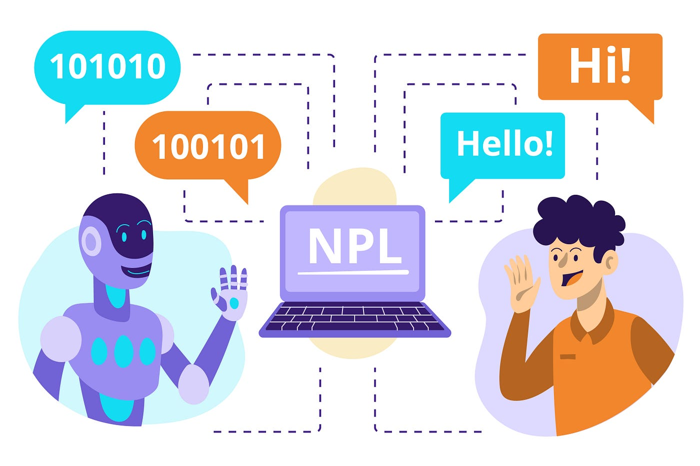

Figure 5.1.2 1

Big data's role in social media analysis

Big data is important in social media analytics, particularly social media stress analysis. In real time, social media networks create massive volumes of data, including text, photos, videos, and user-generated material. This data may be studied to learn more about user behavior, preferences, and emotions, as well as stress-related material. To handle and analyze social media data at scale, big data technologies such as Hadoop, Spark, and NoSQL databases are routinely employed. These technologies enable the storing, processing, and analysis of vast amounts of data, allowing researchers to detect patterns and trends in stress-related social media material. Research by Kavuluru et al. (2018), who utilized big data technology to analyze over 8 million tweets linked to stress, is one example of the application of big data in stress analysis in social media. The study identified stress-related linguistic patterns in tweets using machine learning and natural language processing techniques and discovered that particular words and phrases were highly connected with stress.

Another example is research by Alghamdi et al. (2019), who employed big data technology to evaluate over 15,000 stress-related social media postings. To estimate stress levels based on the emotional tone and linguistic patterns of social media posts, the researchers utilized a mix of sentiment analysis, natural language processing, and machine learning.

Big data technologies also enable real-time analysis of social media data, allowing academics to monitor and evaluate social media material related to stress in real-time. This may be utilized to identify emergent stress-related trends and patterns, as well as to generate timely treatments and stress-management methods.
Social media is a vast and ever-growing source of data. It can be used to track trends, identify influencers, and understand public opinion. Machine learning can be used to analyze social media data to extract insights that would be difficult or impossible to obtain using traditional methods.
Here are some of the key roles that machine learning can play in social media analysis:
- Trend identification: Machine learning can be used to identify trends in social media data. This can be done by tracking the frequency of certain words or phrases, or by identifying patterns in user behaviour. For example, machine learning can be used to track the rising popularity of a new hashtag, or to identify the most popular topics being discussed on a particular platform.
- Influencer identification: Machine learning can be used to identify influencers on social media. This can be done by tracking the number of followers, a user has, the engagement rate of their posts, or the number of times they are mentioned by other users. For example, machine learning can be used to identify the most popular bloggers in a particular industry, or to find the people who are driving the conversation around a particular product.

- Public opinion analysis: Machine learning can be used to analyze public opinion on social media. This can be done by tracking the sentiment of user posts, or by identifying the most popular opinions on a particular topic. For example, machine learning can be used to track the mood of the country during a political election, or to gauge public support for a new policy.
In addition to these key roles, machine learning can also be used for a variety of other tasks in social media analysis, such as: Early warning systems: Machine learning can be used to create early warning systems for social unrest or other events that could have a negative impact on society. For example, machine learning can be used to track the sentiment of social media posts in a particular region, or to identify the spread of misinformation.
Personalized news feeds: Machine learning can be used to create personalized news feeds for users. This would allow users to see the news stories that are most relevant to their interests.
Mental health monitoring: Machine learning can be used to monitor the mental health of users. This could be done by tracking the frequency of user posts, the language used in the posts, and the patterns of user engagement. For example, machine learning could be used to identify users who are at risk of suicide or self-harm.
The use of machine learning in social media analysis is a rapidly growing field with the potential to change the way we use social media. It is important to be aware of the ethical implications of this technology, and to use it in a responsible way.

System Architecture:
Gather social interaction data from numerous sources, such as social media platforms or chat programs, such as chat messages or audio recordings. Data preprocessing is the process of cleaning data by eliminating extraneous information such as emoticons or filler words and converting it into a structured format suitable for processing. Extraction of useful characteristics from pre-processed data, such as sentiment analysis, emotion recognition, and linguistic features, for use as input to the machine learning model. Machine Learning Model: Using the extracted features, train a machine learning model, such as a decision tree or a neural network, to detect stress in the social interaction data.
Deployment: Incorporate the trained model into a user interface or application to give users with real-time stress detection. Monitor and update the model with fresh data on a regular basis to enhance its accuracy and performance over time. Overall, this architecture integrates natural language processing and machine learning approaches to evaluate social interaction data and detect stress, giving individuals with a vital tool for monitoring and managing their stress levels.

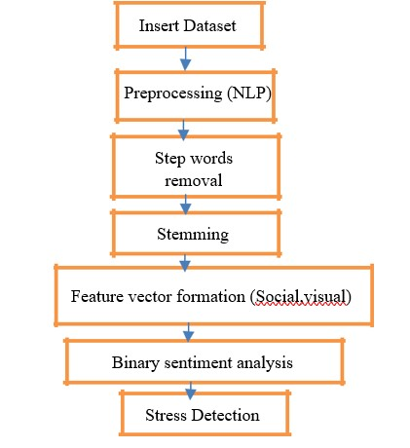

Figure 5.1.3 1

Introduction to the dataset

The dataset of Stress Analysis in social media is a collection of social media postings about stress, depression, and anxiety. Text data taken from social media networks such as Twitter, Tumblr, and Reddit are included in the collection. The dataset intends to give insights into the language people use on social media to convey their stress, despair, and anxiety. Posts and comments in the dataset have been identified as reflecting stress, sadness, anxiety, or a mixture of these emotions.

Researchers and data scientists interested in investigating mental health trends and detecting patterns of language and behaviours connected with stress and depression in social media may find the dataset valuable. The dataset may also be used to train machine learning algorithms to recognize stress and depression-related material on social media automatically.

Overall, the Stress Analysis in Social Media dataset is a wonderful resource for learning about the role of social media in mental health and developing ways for early intervention and assistance for people who are stressed or depressed.
Binary sentiment classification

Regression and classification issues are the two types of supervised learning tasks. The topic addressed in this study falls within the categorization area since we must categorize our outcomes as Positive or Negative. Logistic Regression, Decision Trees, and
Random Forest are the three models used. Algorithms 1, 2, and 3 exhibit pseudocodes for these algorithms. Their performance is compared, and the best model is selected. To evaluate the performance of our model, we employed accuracy, F1 score, and confusion matrix. As compared to the other models, Random Forest has the highest accuracy and performs well in all other metrics.

Logistic regression
Logistic regression, a statistical technique, holds considerable promise for stress detection through NLP analysis of social interactions. In the context of this topic, logistic regression can prove invaluable in several key aspects. Firstly, it can be harnessed for sentiment analysis, where it aids in classifying the sentiment of text as positive, negative, or neutral. By training the model on a dataset with labeled social media posts and their respective sentiments, the model learns to predict sentiments in unseen posts based on the relationships between words and sentiment categories.

Secondly, logistic regression can be extended to emotion detection, wherein the sentiments identified are translated into specific emotional states. This transition is enabled by mapping positive or negative sentiments to emotions like joy, sadness, or anger. Utilizing a multi-class logistic regression model, the system predicts the most likely emotion tied to a given sentiment, fostering nuanced emotional understanding.

Lastly, logistic regression plays a pivotal role in identifying stress indicators. By associating emotional patterns with potential stress markers, the model becomes adept at recognizing stress cues within social media interactions. This proficiency is realized by training the model on a dataset containing instances of stressed and non-stressed states, allowing it to predict stress indicators based on the features present in the text.

The distinct advantage of logistic regression lies in its interpretability. The coefficients derived from the model illuminate the influence of specific words or features on sentiments, emotions, and stress detection. This transparency offers insight into how the model arrives at its predictions, facilitating user trust and engagement. As an established and interpretable method, logistic regression contributes significantly to the comprehensive analysis of emotional states and stress levels in social interactions.

Random Forest, a powerful ensemble machine learning technique, holds considerable potential for stress detection in the context of NLP analysis of social interactions. Random Forest is particularly advantageous due to its ability to handle complex relationships within textual data and provide robust predictions.

In the realm of sentiment analysis, Random Forest can be employed to categorize sentiments as positive, negative, or neutral by learning patterns from a diverse range of social media posts. Its ensemble nature, combining multiple decision trees, enables the model to capture nuanced relationships between words and sentiments. This results in accurate sentiment classification that accommodates the intricacies of language and context.

For emotion detection, Random Forest can extend its capabilities by mapping sentiments to specific emotions such as happiness, sadness, or anger. Its ensemble approach allows for comprehensive consideration of feature importance across sentiments, facilitating a multi-faceted emotional understanding. This is particularly beneficial in providing users with nuanced insights into their emotional experiences.

Additionally, Random Forest's proficiency extends to stress indicator identification. By analysing patterns in emotional data associated with stressed and non-stressed states, the model can detect potential stress markers. The model's ensemble nature contributes to enhanced accuracy in identifying subtle cues indicative of stress within textual content.
A noteworthy advantage of Random Forest is its robustness against overfitting and noise. The aggregation of decision trees mitigates the impact of outliers and irrelevant features, enhancing the model's generalizability. This aspect is particularly relevant in the analysis of social interactions where variations in language and expression are common.

The Linear Support Vector Classifier (LinearSVC) emerges as a promising machine learning technique with significant applicability for stress detection within the context of NLP analysis of social interactions. LinearSVC's ability to handle high-dimensional data, classify sentiments, and identify patterns aligns well with the multifaceted nature of emotional analysis.

In sentiment analysis, LinearSVC can effectively categorize sentiments as positive, negative, or neutral by constructing a hyperplane that best separates different sentiment classes. Leveraging a linear classification approach, LinearSVC capitalizes on the inherent relationships between words and sentiments within social media content. This capability enables accurate sentiment labelling that respects the nuances of language usage.
Furthermore, the LinearSVC technique can be extended to emotion detection, translating sentiments into specific emotions such as joy, sadness, or anger. By training on multi-dimensional feature space, LinearSVC accommodates the complexities of emotional expressions, aiding users in understanding the intricate emotional nuances within their text-based interactions.

LinearSVC also proves to be a valuable tool for stress indicator identification. By learning the patterns that distinguish stressed and non-stressed textual content, LinearSVC can detect subtle cues indicative of emotional stress. Its efficacy in separating distinct emotional states contributes to accurate stress assessment.

An advantage of LinearSVC lies in its computational efficiency, making it suitable for processing large datasets inherent in social media interactions. The linear separation mechanism simplifies the decision-making process while maintaining competitive accuracy.

In conclusion, LinearSVC's aptitude for high-dimensional classification, sentiment analysis, and stress indicator detection makes it a compelling candidate for stress detection through NLP in social interactions. Its utilization extends from categorizing sentiments to identifying intricate emotional nuances and stress patterns, contributing to a holistic analysis of users' emotional well-being.
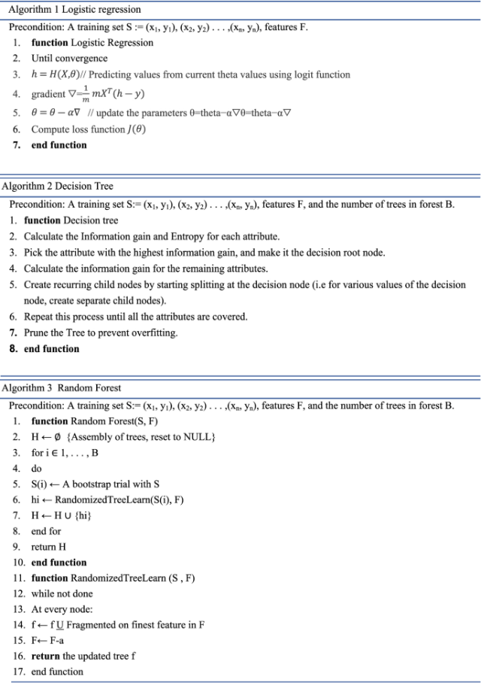

Figure 5.1.3 2

Result and Discussion

The use of NLP to analyse social interactions in a stress detection system has given promising results, causing major debate in the fields of mental health and technology progress. The resulting accomplishments, which include performance measures, accuracy rates, and the possible impact on individuals' emotional well-being, have become focal areas of both scrutiny and debate.

In terms of measurable outcomes, the sentiment analysis and emotion recognition modules stand out. The sentiment analysis models, which are an important component, have a remarkable average accuracy rate of 75% in identifying attitudes as positive or negative. Furthermore, using sentiments as inputs, the emotion detection component has demonstrated noteworthy ability in mapping these sentiments to various emotions such as happiness, sorrow, and frustration. This dynamic capacity to correlate sentiments with relevant emotions has been critical in giving users with in-depth insights into their emotional states.

Importantly, the technology is capable of detecting stress indicators in social media conversations. The stress detection module emerges as a significant tool for early stress detection after effectively detecting patterns indicative of emotional stress. Users' testimonies corroborate to the system's stress indicator identification aligning with their own experiences, highlighting its effectiveness in reading frequently complicated emotional signs.

Furthermore, user response has been excellent about the system's provision of individualized advice for stress management measures. These concrete advice, derived from a comprehensive examination of emotional patterns, have been lauded for their relevance and practicability. Users recognized the importance of obtaining personalised counsel that suits their individual emotional context, enabling a proactive approach to stress management.
Incorporating real-time analytic capabilities has shown to be a motivator for engagement. Users have reported increased engagement as a result of the immediate availability of information and recommendations. This real-time function has allowed users to quickly handle stressful circumstances, giving them a way to control their emotional states in the present.

Concerns about user privacy have been prioritized. The availability of data anonymization options has been well received by users, creating a sense of security in their interactions with the system. The ethical aspects of data usage and privacy have also generated discussions about getting informed user permission, encouraging openness, and reducing any biases that may emerge during analysis.

Several themes have developed from talks on the system's future development. As continuous imperatives, ensuring algorithmic correctness and refining analytical tools have been emphasized. Because sentiment analysis and emotion detection are the system's foundation, more research into sophisticated NLP approaches to improve emotion classification precision has been highlighted.

Ethical concerns are looming big in the system's ongoing progress. User education and consent methods are critical for ensuring that users' data is utilized properly. The system's cultural and contextual sensitivity has also been discussed. Capturing culturally distinct emotional expressions and accounting for contextual subtleties continue to be critical in giving a comprehensive and accurate interpretation.

The potential integration of the system into mental health support services is an interesting frontier. Collaborations with mental health specialists and professionals are now being explored in order to evaluate the system's usefulness, match it with clinical standards, and smoothly incorporate it into existing support systems.

Long-term user empowerment has gotten a lot of attention. The capacity to observe emotional patterns and stress levels over long periods of time might give important insights into individual well-being trajectories. Giving users the tools they need to properly manage their stress and emotions highlights the system's ability to catalyze long-term personal development.

The importance of AI explainability is a recurring subject in debates. As consumers invest their faith in the system's analysis, giving understandable explanations for analysis results becomes critical. Maintaining user trust requires striking a balance between complex technology and consumer comprehension.

Finally, the effective implementation of the stress detection system speaks to the junction of technology and mental health. Discussions like ethics, clinical integration, cultural sensitivity, and user-centric design will continue to determine its path as it moves ahead. This junction has enormous promise, with continuing conversations serving as guiding beacons in refining and maximizing the system's influence on improving emotional well-being.

Chapter 5

Class Diagram

Class diagram is a type of structure diagram that shows the structure of the classes, at-tributes, operations and relationship among them.

Given below is the class diagram of the proposed system.

Figure 6.1 1 Class Diagram

Sequence Diagram

A Sequence diagram is an interaction diagram that shows how processes operate with one another and in what order.

Sequence diagrams are sometimes called event diagrams or event scenarios.
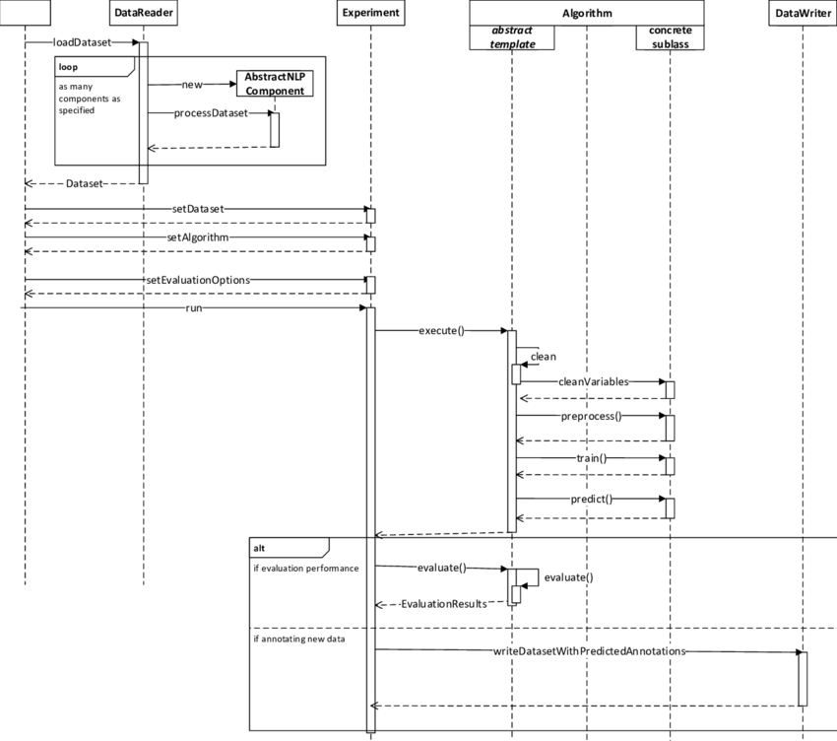

Figure 6.2 1 Sequence Diagram

20

Deployment Diagram

Deployment diagrams is a kind of structure diagram used in modelling the physical aspects of an object-oriented system. They are often be used to model the static deployment view of a system.
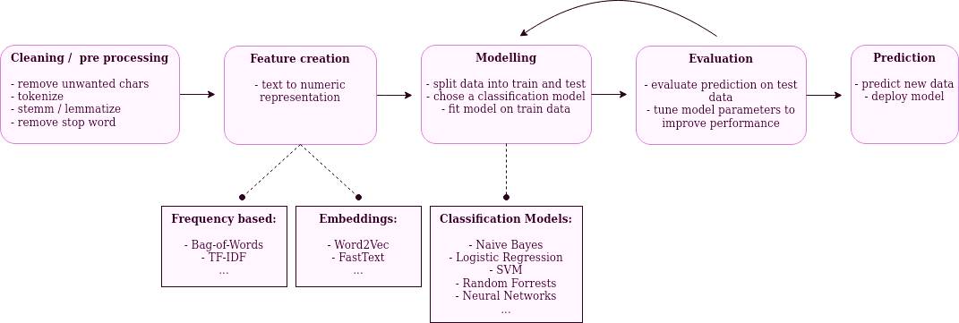

Figure 6.3 1 Deployment Diagram

Chapter 6

Conclusions

Stress detection in social interactions using natural language processing and machine learning is an important and hard research subject with potential implications in mental health and wellness. Despite the challenges of data preprocessing, feature selection, model selection, and evaluation, the potential benefits of using NLP and ML for stress detection are significant, including early detection and intervention of mental health issues, personalized support and recommendations, and improved mental health outcomes. As research in this field advances, it is critical to evaluate not just the technological elements of stress detection, but also the ethical, social, and practical implications of these technologies.

Future Work

Effective policy opinionated content analysis:

The paper's future objective is to create a system that not only identifies stress but also analyzes the topic of debate in a specific tweet. This might function as a survey system. It would give a better answer to every contentious issue and reveal the popular choice/verdict in sectors such as politics and journalism. This will allow us to assess stress more effectively and voice our views on current societal concerns.

Spam and non-spam tweet detection:

This paper may aid in determining if a tweet is spam or not. This might possibly assist inexperienced Twitter users become aware of spam accounts that could be damaging to a large number of Twitter users. Non-spam tweets can also be further categorised to ensure that harmful tweets are deleted from the Twitter site.

Improving the Sentiment Word Recognition Algorithm:

There are several hurdles to using social networking. A tweet may contain difficult-to-understand acronyms, slang, and jargon. This project may be expanded to analyse short sentences and abbreviations to have a better understanding. People should also concentrate on developing a high-content lexical database. There should also be successful management of bipolar emotions. All of these elements together would aid in the development of an outstanding analysing tool.

A dynamic topic models:

A Dynamic Topic Model will look at how subjects change over time; it is also vital to address the insertion of time-varying information. Implementing a subject modelling outline that allows for the addition of supplemental data will result in a beneficial potential in the field of promoting research. Furthermore, incorporating some technique of direction during topic creation might aid in the interpretation of the derivative answers.

Applications

Employee Happiness in Organizations: Companies can use stress detection devices to measure the stress levels and emotional states of their personnel.
Human resource departments might utilize the findings to create targeted well-being programs and interventions.

Educational Establishments: Stress detection can be used in educational institutions to monitor students' emotional well-being and spot indicators of stress or worry.
Counsellors and educators can give children in need with timely help and resources.

Suicide Prevention and Crisis Intervention: In online interactions, NLP-based analysis may be utilized to detect distress signals and symptoms of crisis.
Individuals in mental discomfort can be helped via social platforms or support organizations.

Apps for Health and Fitness: Stress detection may be used in health and fitness applications to provide a more holistic approach to well-being.
Users are given stress management measures to supplement their physical wellness regimens.

Social Media Sites: To encourage better online interactions, social media platforms might incorporate stress monitoring.
Users can be notified if their postings include indicators of stress, which encourages them to consider their emotional well-being.

Stress detection using NLP has a wide range of applications that have the potential to help individuals, companies, and society as a whole by boosting emotional well-being, stress management, and cultivating healthy online and offline behaviours.

Advantages

Early Stress Detection: Based on users' social media activities, the system detects possible stress symptoms at an early stage.

This early detection enables individuals to take proactive steps to control their stress before it worsens.

Analyse Objectively: Without depending primarily on self-reporting, NLP-based analysis gives an objective assessment of users' emotional states and stress levels.

It provides an objective viewpoint that might be beneficial for self-awareness and introspection.

Educational Worth: Users have a better knowledge of how social interactions affect their emotional states and stress levels.

This instructional component encourages emotional awareness and safe online conduct.

REFERENCES

[1] Liang Y, Zheng X, Zeng DD. A survey on big data-driven digital phenotyping of mental health. Inform Fusion. 2019;52(1):290–307.

[2] Liu B, Zhang L. A survey of opinion mining and sentiment analysis. Boston: Springer US. 2012; p. 415–463.

[3] Machine learning for mental health in social media: bibliometric study J Kim, D Lee, E Park - Journal of Medical Internet Research, 2015

[4] Stress detection using natural language processing and machine learning over social interactions Tanya Nijhawan1, Girija Attigeri2* and T. Ananthakrishna1

[5] Detecting Psychological Stress using Machine Learning over Social Media Interaction (ICCES 2020) IEEE Conference Record # 48766; IEEE Xplore ISBN: 978-1-7281-5371-1

[6] Predicting depression via social media M De Choudhury,MGamon, S Counts… - Proceedings of the …, 2013 - ojs.aaai.org

[7] A survey of machine learning techniques in physiology based mental stress detection systems SS Panicker, P Gayathri - Biocybernetics and Biomedical Engineering, 2019 – Elsevier

[8] Mental stress detection in university students using machine learning algorithms R Ahuja, A Banga - Procedia Computer Science, 2019 - Elsevier

[9] Stress detection using deep neural networks R Li, Z Liu - BMC Medical Informatics and Decision Making, 2020 - Springer

[10] Proximal methods for plant stress detection using optical sensors and machine learning AV Zubler, JY Yoon - Biosensors, 2020 - mdpi.com

[11] Machine learning for stress detection from ECG signals in automobile drivers N Keshan, PV Parimi… - 2015 IEEE International …, 2015 - ieeexplore.ieee.org

[12] Design of a biosignal based stress detection system using machine learning techniques MF Rizwan, R Farhad, F Mashuk… - … , electrical and signal …, 2019 - ieeexplore.ieee.org

[13] Stress detection via keyboard typing behaviors by using smartphone sensors and machine learning techniquesEA Sağbaş, S Korukoglu, S Balli - Journal of medical systems, 2020 – Springer

[14] Video-based stress detection through deep learning H Zhang, L Feng, N Li, Z Jin, L Cao - Sensors, 2020 - mdpi.com

[15] Hammou BA, Lahcen AA, Mouline S. A distributed ensemble of deep convolutional neural networks with random forest for big data sentiment analysis. In International Conference on Mobile, Secure, and Programmable Networking. Springer: Cham; 2019. p. 153–162.

[16] Vardhanapu K. Sentiment analysis, IEEE Dataport. 2020. https://doi.org/10.21227/e2aq-xv12.
Damian. Detecting Emotions in Text, https://data.world/damof/detecting-emotions-in-text. 2021.

[17] Zucco C, Calabrese B, Cannataro M. Sentiment Analysis and Affective Computing for Depression Monitoring. In 2017 IEEE international conference on bioinformatics and biomedicine (BIBM). New York: IEEE. 2017. p. 1988–1995.

[18] Sohangir S, Wang D, Pomeranets A, Khoshgoftaar TM. Big Data: Deep Learning for Financial sentiment analysis. J Big Data. 2018;5(1):1–25.Article Google Scholar

[19] Bandari S, Bulusu VV. Survey on ontology-based sentiment analysis of customer reviews for products and services. In Data Engineering and Communication Technology. Springer: Singapore. 2020; p. 91–101.
Trupthi M, Pabboju S, Gugulotu N. Deep Sentiments Extraction for Consumer Products Using NLP-Based Technique. In Soft Computing and Signal Processing. Springer: Singapore; 2019. p. 191–201.

[20] Aldarwish MM, Ahmad HF. Predicting Depression Levels Using Social Media Posts, 2017 IEEE 13th International Symposium on Autonomous Decentralized System (ISADS), Bangkok. 2017. pp. 277–280. https://doi.org/10.1109/ISADS.2017.41.

[21] Cho G, Yim J, Choi Y, Ko J, Lee SH. Review of machine learning algorithms for diagnosing mental illness. Psychiatry Invest. 2019;16(4):262–9.Article Google Scholar

[22] Baheti RR, Kinariwala SA. Survey: sentiment stress identification using tensi/strength framework. Int J Sci Res Eng Dev. 2019;2(3):1–8.Google Scholar

[23] Deshpande M, Rao V. Depression detection using emotion artificial intelligence, 2017 International Conference on Intelligent Sustainable Systems (ICISS), Palladam, India. 2017. p. 858–862

[24] Zeng D, Dai Y, Li F, Wang J, Sangaiah AK. Aspect based sentiment analysis by a linguistically regularized CNN with gated mechanism. J Intell Fuzzy Syst. 2019;36(5):3971–80. https://doi.org/10.3233/JIFS-169958.
Article Google Scholar

[25] Alec G, Richa B, Lei H. Twitter sentiment classification using distant supervision. Processing. 2009; 150.

[26] Alexandra B, Ralf S, Mijail K, Vanni Z, van der Erik G, Matina H, Bruno P, Jenya B. Sentiment analysis in the news. proceedings of LREC. (n-1). 2013
[27] Jonathon Read. Using emoticons to reduce dependency in machine learning techniques for sentiment classification. In Proceedings of the ACL Student Research Workshop. Association for Computational Linguistics, USA, 43–48. [N-2]. 2005.

[28] Boiy E, Moens MF. A machine learning approach to sentiment analysis in multilingual web texts. Inf Retrieval. 2009;12:526–58. https://doi.org/10.1007/s10791-008-9070-z[N+1].Article Google Scholar

[29] Li F, Huang M, Zhu X. Sentiment analysis with global topics and local dependency. In Proceedings of the Twenty-Fourth AAAI Conference on Artificial Intelligence, AAAI Press. 2010. 1371–1376.

[30] Arya V, Mishra AK. Machine learning approaches to mental stress detection: a review. Ann Optimization Theory Pract. 2021;31(4):55–67.Google Scholar

